**PAPER TITLE**

**A.F. Klmno 1 P.Q. Rstw 2,3 X. Yzabc 3 D. Efghi 4 J.K. Lmnop 4**

*1. Electrical Engineering Department, … University of …, City, Country, e-mail.account.1@---.---*

*2. Center of …, Faculty of Engineering, … University of …, City, Country, e-mail.account.2@---.---*

*3. Department of …, Organization of …, City, Country, e-mail.account.3@---.---*

*4. … Company, City, Country, e-mail.account@---.---, e-mail.account.4@---.---*

**Abstract-**Permanent magnet synchronous motor (PMSM) have a wide range of applications, such as electric drives and machine ………………………………

…………………………………………………………….

…………………………………………………………….

…………………………………………………………….

…………………………………………………………….

…………………………………………………………….

……………… to ensure stability and tracking. Simulations is carried out to verify the theoretical results.

**Keywords:**PMSM, Modeling, Saturation, ……………, …………., ……………., Lyapunov Stability.

**1. INTRODUCTION**

A broad spectrum of electric machines is widely used in electromechanical systems. In addition to the required ……………………………………………………………

…………………………………………………………….

…………………………………………………………….

…………………………………………………………….

…………………………………………………………….

…………………………………………………………….

…………………………………………………………….

…………………………………………………………….

…………………………………………………………….

…………………………………………………………….

…………………………………………………………….

…………………………………………………………….

…………………………………………………………….

…………………………………………………………….

…………………………………………………………….

…………………………………………………………….

…………………………………………………………….

…………………………………………………………….

…………………………………………………………….

…………………………………………………………….

…………………………………………………………….

…………………………………………………………….…………………………………………………………….

primary issues are studied in this paper. In particular, we perform nonlinear modeling and analysis, controllers design, and validate the theoretical results [1].

**2. NONLINEAR MOTOR DYNAMICS**

A mathematical model of three-phase, two-pole permanent-magnet synchronous motors should be developed. Three-phase, two-pole permanent-magnet synchronous motor is illustrated in Figure 1.

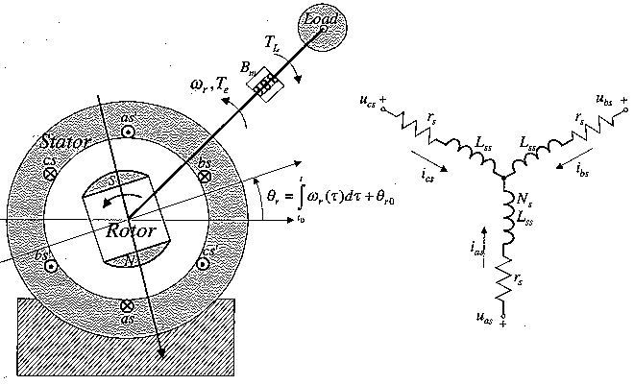

Figure 1. Two-pole permanent-magnet synchronous motor

*Follow the following instructions 1-3 to get high quality figures:*

**1. Change the picture(s) resolution**

Click File -> Options -> Advanced

Select:

**Image Size and Quality**

**√** Do not compress images in file

Default Resolution: **High Fidelity**

OK

**2. Check out the picture(s) resolution**

Click Picture Format -> Compress Pictures

Resolution: **High Fidelity**

**3.** If the picture(s) resolution **is not High Fidelity** then **CHANGE** it with high quality images.

**2.1. Motor Modeling**

For the magnetically coupled abc stator windings, we apply the Kirchhoff voltage law to find a set of the following differential equations in MathType Equation Editor:

 (1)

 (2)

 (3)

…………………………………………………………….

…………………………………………………………….

…………………………………………………………….

…………………………………………………………….

…………………………………………………………….

…………………………………………………………….

…………………………………………………………….

…………………………………………………………….

…………………………………………………………….

…………………………………………………………….

 (5)

 (6)

where the flux linkages are:

 (7)

where  is the stator resistance,  and  are the leakage and magnetizing inductances  and  is the amplitude of the flux linkages established by the permanent magnet.

…………………………………………………………….

…………………………………………………………….

…………………………………………………………….

…………………………………………………………….

…………………………………………………………….

…………………………………………………………….

…………………………………………………………….

…………………………………………………………….

**2.2. Factors Affecting Partial Discharge**

Partial discharge activity in a solid dielectric material depends upon applying voltage, dielectric constant of the material and the size of the void. These are considered as the important factors affecting Partial Discharge in solid dielectrics.

**2.2.1. Applied Voltage**

When the applied high voltage is increased, the electric field is enhanced and the liberation electron rate is increased. As a result more Partial Discharges will occur. High voltage ranging from 4 KV to 20 KV is applied to the simulation model to observe the various activities due to the presence of void, which is done with the help of a laboratory experiment setup.

**2.2.2. Different Sample Materials**

Depending upon different materials used in the insulation model the apparent charge varies. Parameters in Table 1 are simulated using MATLAB to observe the variation of Partial Discharge with different materials used in the sample model. Each material has different dielectric constants.

…………………………………………………………….

…………………………………………………………….

…………………………………………………………….

…………………………………………………………….

…………………………………………………………….

…………………………………………………………….

**2.3. Park Transformation**

Applying the Park transformation, we havethe following expression for the electromagnetic torque:

 (14)

Using Equation (11) and the park transformation, one obtains the following differential equation to model permanent-magnet synchronous motors in the rotor reference frame:

 (15)

 (16)

 (17)

 (18)

where, ,,  and , , are the quadrature, direct, and zero-axis current and voltage components.

The analysis of permanent-magnet synchronous motors in the arbitrary reference frame using the quadrature, direct, and zero-quantities is simple. The electromagnetic torque is a function of the quadrature current  and differential equation for the zero currentcan be omitted from the analysis. We have:

…………………………………………………………….

…………………………………………………………….

…………………………………………………………….

…………………………………………………………….

…………………………………………………………….

…………………………………………………………….

That is, the total derivative of a positive-definite quadratic function  is negative. Hence, an open-loop system is uniformly asymptotically stable [3].

**3. FEEDBACK LINEARIZATION CONTROL**

As a first step toward the design, we mathematically set up the design problem. It is easy to verify that the linearizability condition is guaranteed. Let:

…………………………………………………………….

…………………………………………………………….

…………………………………………………………….

…………………………………………………………….

…………………………………………………………….

*Remark.* In pole-placement design, the specification of optimum (desired) transient responses in terms of system models and feedback coefficients is equivalent to the specification imposed on desired transfer functions of closed-loop systems. Clearly, the desired eigenvalues can be specified by the designer, and these eigenvalues are used to find the corresponding feedback gains. However, the pole-placement concept, while guaranteeing the desired location of the characteristic eigenvalues can lead to positive feedback coefficients and control constraints. Hence, the stability, robustness to parameter variations, and system performance are significantly degraded.

Mathematically, feedback linearization reduces the complexity of the corresponding analysis and design. However, even from mathematical standpoints, the simplification and *"optimum"* performance would be achieved in expense of large control efforts required because of linearizing feedback (25). This leads to saturation. It must be emphasized that the need to linearize (19, 20, 21) does not exist because the open-loop system is uniformly asympotically stable.

The most critical problem is that the linearizing feedback:

…………………………………………………………….

…………………………………………………………….

…………………………………………………………….

…………………………………………………………….

…………………………………………………………….

…………………………………………………………….

…………………………………………………………….

…………………………………………………………….

…………………………………………………………….

Hence, the feedback linearizing controllers cannot be implemented to control synchronous machines. It is desirable, therefore, to develop other methods to solve the motion control problem, methods that do not entail the applied voltages to the saturation limits to cancel beneficial nonlinearities  ,and ,and methods that do not lead to unbalanced motor operation.

**4. THE LYAPUNOV-BASED APPROACH**

In this section, the design is approached using a nonlinear model. Using Equations (19), (20) and (21), we have the following matrix form:

…………………………………………………………….

…………………………………………………………….

…………………………………………………………….

…………………………………………………………….

…………………………………………………………….

…………………………………………………………….

The feedback coefficients andcan be found by solving nonlinear matrix inequalities. Applying the Lyapunov stability theory and generalizing the results above, the stability of the resulting closed-loop system can be examined studying the criteria imposed on the Lyapunov function. For the bounded reference signal, using the positive-definite quadratic function

…………………………………………………………….

…………………………………………………………….

…………………………………………………………….

…………………………………………………………….

…………………………………………………………….

…………………………………………………………….

…………………………………………………………….

…………………………………………………………….

# 5. SIMULATION RESULTS

In this section, we design a tracking controller for a electromechanical system. We use a Kollmorgen four-pole permanent-magnet synchronous motors H-232 with the following rated data and parameters: 135 W, 434 rad/sec, 40 V, 0.42 N.m, 6.9 A, , ,or 

and 

…………………………………………………………….

…………………………………………………………….

…………………………………………………………….

…………………………………………………………….

…………………………………………………………….

…………………………………………………………….

This controller is bounded. The sufficient criteria for stability are satisfied. To study the transient behavior, a controller is verified through comprehensive simulations. Different reference velocity , loads , and initial conditions

The applied phase voltages and the resulting phase currents in the as *bs* and *cs* windings are illustrated in Figure 2. Figure 3 documents the motor mechanical angular velocity. The setting time for the motor angular velocity as motor starts from stall is 0.0025 sec. The disturbance attenuation features are evident. In particular, the assigned angular velocity with zero steady-state error has been guaranteed when the rated load torque was applied.

Figures 2 and 3 illustrate the dynamics of the closed –loop drive for the following reference speed and load torque:

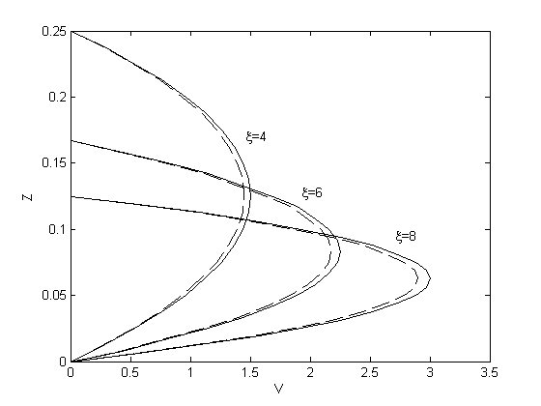

Figure 2. Radial-velocity profiles for different rates

…………………………………………………………….

…………………………………………………………….

…………………………………………………………….

…………………………………………………………….

…………………………………………………………….

…………………………………………………………….

…………………………………………………………….

…………………………………………………………….

…………………………………………………………….

…………………………………………………………….

…………………………………………………………….

…………………………………………………………….

…………………………………………………………….

…………………………………………………………….

…………………………………………………………….

…………………………………………………………….

…………………………………………………………….

…………………………………………………………….

…………………………………………………………….

…………………………………………………………….

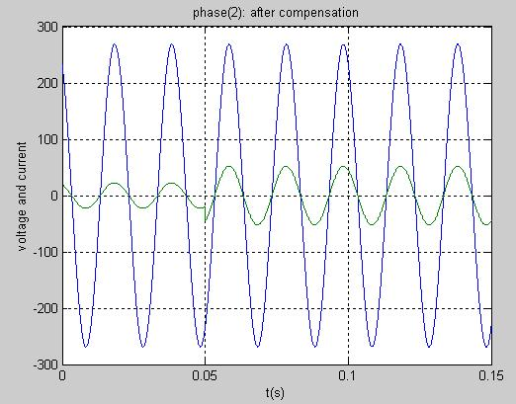

Figure 9. Source side voltage and current of phase (2)

**6. CONCLUSIONS**

Permanent-magnet synchronous motors are used in a wide range of electromechanical systems because they are simple and can be easily controlled. The steady-state torque-speed characteristics fulfil the controllability criteria over an entire envelope of operation. In this paper a bounded controller is designed and sufficient criteria for stability are satisfied. Different reference velocity, loads, and initial conditions are studied to analyze the tracking performance of the resulting system.

…………………………………………………………….

…………………………………………………………….

…………………………………………………………….

**AppendiCES**

## Appendix 1. Construction Cost and Characteristics of 230 and 400 kV Lines

Tables 8 and 9 show the construction costs of 230 and 400 kV lines. Also, characteristics of these lines are listed in Table 10.

Table 10. Construction cost of 230 kV

|  |  |  |
| --- | --- | --- |
| Variable Cost of Line Construction  (×103 dollars) | Fix Cost of Line Construction  (×103 dollars) | Number of Line Circuits |
| 45.9 | 546.5 | 1 |
| 63.4 | 546.5 | 2 |

Table 11. Construction cost of 400 kV

|  |  |  |
| --- | --- | --- |
| Variable Cost of Line Construction  (×103 dollars) | Fix Cost of Line Construction  (×103 dollars) | Number of Line Circuits |
| 92.9 | 1748.6 | 1 |
| 120.2 | 1748.6 | 2 |

Table 12. Characteristics of 230 kV lines

|  |  |  |  |
| --- | --- | --- | --- |
| Resistance (p.u/Km) | Reactance (p.u/Km) | Maximum Loading (MVA) | Voltage Level |
| 1.22e-4 | 3.85e-4 | 397 | 230 |
| 3.5e-5 | 1.24e-4 | 750 | 400 |

## Appendix 2. GA and Other Required Data

## Load growth coefficient = 1.08; Inflation coefficient for loss = 1.15; Loss cost in now = 36.1 ($/MWh); Number of initial population = 5; End condition: 3500 iteration after obtaining best fitness (N=3500); LLmax = 30%.

…………………………………………………………….

…………………………………………………………….

…………………………………………………………….

…………………………………………………………….

…………………………………………………………….

…………………………………………………………….

…………………………………………………………….

…………………………………………………………….

…………………………………………………………….

…………………………………………………………….

…………………………………………………………….

…………………………………………………………….

# NOMENCLATURES

**1. Acronyms**

*CHCP* Combined Heat, Cooling and Power

*CHP* Combined Heat and Power

*COP* Coefficient of Performance

*DG* Distributed Generation

**2. Symbols / Parameters**

**: The number of gas and heat units

**: The number of water units

**: The whole production expense

**: The fuel expense of its unit

*:* The load of net in *t* moment

*:* The cycling reserve load

*:* The production power of *i* heat unit

*:* The production power of *j* water unit

*:* The reserve power of *i* water unit

*:* The reserve power of *j* water unit

*:* The starting expense of *i* heat unit

*:* The starting expense of *j* water unit

**: The subtitle related to interval

**: The time of a complete period under consideration

**ACKNOWLEDGEMENTS**

The author(s) sincerely thank …, Department of Abcd, Faculty of Efgh, University of Ijkl, City, Country for assisting with ...

The author(s) appreciate the assistance of the staff of the Abcd University, City, Country for supporting …

Special thanks go to …

The author(s) grateful to / extend their gratitude to / would like to thank / gratefully acknowledge …

**REFERENCES**

[1] G.A. Taylor, M. Rashidinejad, Y.H. Song, M.R. Irving, M.E. Bradley, T.G. Williams, “**Algorithmic Techniques for Transition Optimized Voltage and Reactive Power Control”,** International Conference on Power System Technology, Vol. 3, No. 2, pp. 1660-1664, 13-17 Oct. 2002.

[2] J. Zhong, E. Nobile, A. Bose, K. Bhattacharya, “**Localized Reactive Power Markets Using the Concept of Voltage Control Areas”,** IEEE Transactions on Power Systems, Vol. 19, Issue 3, pp. 1555-1561, Aug. 2004.

[3] A.B. Author1, “Title of the Book”, Ghijk Press, City, Country, Year.

[4] A. Author1, C.D Author2, “Title of the Conference Paper”, 8th International Conference on Technical and Physical Problems of Electrical Engineering (ICTPE-2013), No. 10, Code 01CPE05, pp. 42-48, City, Country, 9-11 September 2013.

[5] A.B. Author1, C. Author2, D.E.F. Author3, “Title of the Journal Paper”, International Journal on Technical and Physical Problems of Engineering (IJTPE), Issue 12, Vol. 4, No. 3, pp. 79-86, September 2012.

[6] http://www.abcd.efgh_ijk.LMN/.../opqr.pdf.

**BIOGRAPHY / BIOGRAPHIES**

*- Include the photo(s) of the author(s) with high quality and color based in the Biographies section. The photos should be in high resolution, color status and size of 2.5×2 cm. Taken in full-face view directly facing the camera.*

*Improve the poor quality of the author(s)’ photo(s) using IMAGE ENHANCER tools/services.*

Resolution: **High Fidelity**

*-* *Fill in the items of the following form for all of the authors* *separately at the end of the paper.*

|  |
| --- |
| Name: **Abcde**  Middle Name: **Fghij**  Surname: **Klmno**  Birthday: dd.mm.yyyy  Birthplace: City, Country  Bachelor: Field/Title, Department, Faculty, University/Institute, City, Country, Year of Graduation  Master: Field/Title, Department, Faculty, University/Institute, City, Country, Year of Graduation  Doctorate: Field/Title, Department, Faculty, University/Institute, City, Country, Year of Graduation  The Last Scientific Position: Academic/Prof./Assoc. Prof./Assist. Prof./Lecturer/(Bachelor/Master/Doctorate) Student, Department, Faculty, University/Institute, City, Country, Since Year  Research Interests: Field 1, Field 2, Field 3  Scientific Publications: ? Papers, ? Books, ? Patents, ? Projects, ? Theses  Scientific Memberships: Organization 1, Organization 2, Organization 3 |

**Select one Conference Topic for your submitted paper from the following link:**

<http://www.iotpe.com/ICTPE/ICTPE-2020/ConferenceTopics.html>

e.g.: **1. Power and Energy Systems (01PES)**